PROJECT REPORT

VOICE IDENTITY DOOR LOCK



RAJIV GADHI GOVT. ENGINEERING COLLEGE NAGROTA BAGWAN

NAME – SHIV KUMAR

ROLL NO. - 1603617045

SEMESTER – 7TH

ELECTRONICS AND COMMUNICATION ENGINEERING

**Table of content**

Introduction……………………………………………………………….………………

Abstract……………………………………………………………………………………..

Project components Details…………….…………………………………………

1. Voice Recognition module……………………………..
2. Relay………………………………………………………….…..
3. Solenoid Lock…………………………………………....…..
4. Power supply…………………………………………………
5. Arduino……………….…………………………………..……..
6. 9 Volt Battery……………………………………………….…
7. Jumper wires………………………………………………….

Methodology…………………………………….………………………………………..

Security Concern…………………………….…………………………………………..

Purpose of this project………………………………………………………………..

References………………………………………………………………………………….

**ACKNOWLEDGEMENT**

The completion of this study would have been not possible if not dependent on the steadfast support and encouragement of Prof. **Mr. Ashish Sharma**. They hence paid equal contribution to the study for which I always feel profound gratitude in my heart.

I would like to express here the very thanks to my dissertation advisor, Prof. **Mr. Ashish Sharma**, Astt. Professor of ECE department, who provided me the opportunity to do experiments in his laboratory.

I also owe my special thanks to from all the members who contributed and who are contributing to this project, was vital for the success of the project. I am grateful for their constant support and help.

**GENERAL INFORMATION**

Project Title: Voice Identity Door Lock

Duration in months : 4

Principal Investigator: Mr. Ashish Sharma

Designation: Assistant professor

Department: Electronics and communication Engineering

Institute Name: Rajiv Gandhi Govt. Engg. College, Nagrota Bagwan

Address: Vill. Massal Teh. Nagrota Bagwan Distt. Kangra

Project Group Members :- Name(Roll no.)

ANKITA (1603617010)

PARTIKSHA (160367035)

PREZY SOOD (1603617038)

RIYA SHARMA (1603617042)

SHIV KUMAR (1603617045)

**PROJECT -1**

**NAME**- **VOICE IDENTITY DOOR LOCK**

**INTRODUCTION**

**Objective:**-

The project aim is to develop **a VOICE IDENTITY DOOR** so that it can open only through Voice of specified person. Our objective is to make the electronic devices cost effective so the common person can use this. Due to this project the security of the house, drawers etc. can increase.

**Requirements**:-

1. SolenoidLock (12V)
2. Arduino UNO
3. Relay (5V)
4. FIW 9V Battery
5. Microphone and Voice Recognition Module
6. Jumper Wires(M-M,M-F,F-F)
7. 5V Power Supply

**TECHNICAL DETAILS:-**

We use c ++ language for programming in this project. The programming is done with the help of Arduino UNO. The programmed devices are Electronic Hasp. The voice is recorded through Electret Microphone Amplifier MAX4466 Mike for password lock. For connection we use jumper wires (F-F, M-M, F-M connectors).

**ABSTRACT**

Speech recognition is a sub field of computational linguistics that develops methodologies and technologies that enables the recognition and translation of spoken language into text by computers. It is also known as **automatic speech recognition** (ASR**), computer speech recognition** or **speech to text** (STT). It incorporates knowledge and research in the linguistics, computer science and electronic engineering fields.

The system we are using is speaker dependent that mean we are using training. A speaker dependent system is intended for use by single speaker. With isolated speed single words are used, therefore it become easy to recognize the speech. Speech recognition application includes Voice User Interface such as voice dialing (e.g. “OPEN THE DOOR” or “CLOSE THE DOOR”).

Recognizing the speaker can simplify the task of translating speech in systems that have been trained on a specific person’s voice. It can be used to authenticate or verify the identity of a speaker as security process. We are using Speech Recognition Technique for **VOICE IDENTITY DOOR LOCK** as a best example of **Home Automation.**

The aim is to develop **a VOICE IDENTITY DOOR** so that it can open only through Voice of specified person. Programs may have problems recognizing speech as normal if our voice changes, e.g. when we have a cough, cold or throat problem. This paper proposes the development of a home automation voice command system.

The system was modeled using some of the **ELECTRONIC** elements in a way to be flexible, and adaptable towards any residence structure. This means that, any user is able to dynamically add and remove electronic devices into the system without the help of a technician. It was designed and voice recognition module application, which communicates in a local network with an **Arduino board.** In order to assess the system, it was built a miniaturized residence to test it in a real case scenario. The findings suggest that the system works relatively well; however, there were a few Instances that the system could not recognize the content properly.

**PROJECT COMPONENT DETAILS:-**

1. **VOICE RECOGNITION MODULE:-**

ELECHOUSE Voice Recognition Module is a compact and easy-control speaking recognition board.

This product is a speaker-dependent voice recognition module. It supports up to 80 voice commands in all. Max 7 voice commands could work at the same time. Any sound could be trained as command. Users need to train the module first before let it recognizing any voice command.

This board has 2 controlling ways:

1. Serial Port (full function),
2. General Input Pins (part of function).

General Output Pins on the board could generate several kinds of waves while corresponding voice command was recognized.

Speech recognition is a sub field of computational linguistics that develops methodologies and technologies that enables the recognition and translation of spoken language into text by computers.

It is also known as **automatic speech recognition** (ASR**), computer speech recognition** or **speech to text** (STT). It incorporates knowledge and research in the linguistics, computer science and electronic engineering fields. The system we are using is speaker dependent that mean we are using training.

A speaker dependent system is intended for use by single speaker.With isolated speed single words are used, therefore it become easy to recognize the speech. Speech recognition application includes Voice User Interface such as voice dialing (e.g. “OPEN THE DOOR” or “CLOSE THE DOOR”).Recognizing the speaker can simplify the task of translating speech in systems that have been trained on a specific person’s voice.

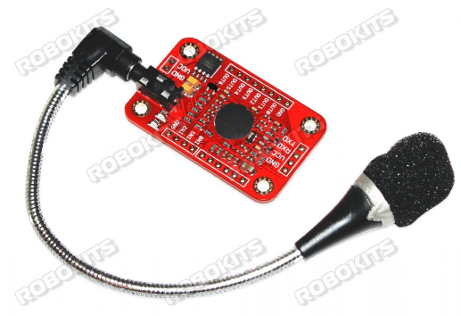

**Fig.1 VOICE RECOGNITION MODULE**

It can be used to authenticate or verify the identity of a speaker as security process. Task and language constraints

1. E.g. Querying applications may dismiss the hypothesis “OPEN THE DOOR”.
2. E.g. Constraints may be semantic; rejecting “OPEN THE FLOOR”.
3. E.g. Syntactic; rejecting “DOOR OPEN THE”.

We are using Speech Recognition Technique for **VOICE IDENTITY DOOR LOCK** as a best example of **Home Automation.**

### **Parameter**:-

* Voltage: 4.5-5.5V
* Current: <40mA
* Digital Interface: 5V TTL level for UART interface and GPIO
* Analog Interface: 3.5mm mono-channel microphone connector +  microphone pin interface
* Size: 31mm x 50mm

### **Feature**:-

* Support maximum 80 voice commands, with each voice 1500ms (one or two words speaking)
* Maximum 7 voice commands effective at same time
* Arduino library is supplied
* Easy Control: UART/GPIO

1. **RELAY:-**

**Relay** is a switch, which opens and closes the circuit electronically. It uses electromagnetism from small voltage to provide higher voltages. It has two basic contacts i.e. NO (Normally Open) and NC (Normally Closed). When input voltage is applied across its coil, NC changes to NO and NO changes to NC. When input voltage is supplied, we say that the relay is energized. It has several features e.g. it can be used for switching smaller voltage to higher. But it cannot be used in power consuming devices. It has a wide range of applications. It can be used in home appliances, electronic circuits where there is a need of protection, robotics for controlling its motors from the proper motion and many more.

**RELAY PIN:-**

* Relay has total five (5) pins with different individual functions.
* Three pins are at one side of the structure.
* The other two pins are on the opposite side of the structure.
* All of these pins are provided in the table given in the figure shown below.

|  |  |
| --- | --- |
| RELAY PINS | |
| PIN NO. | PIN NAME |
| 1 | COIL (COIL TERMINAL) |
| 2 | COM (COMMON/MOVABLE CONTACT) |
| 3 | COIL (COIL TERMINAL) |
| 4 | NO (NORMALLY OPEN) |
| 5 | NC (NORMALLY CLOSED) |

**RELAY PIN DESCRIPTION:-**

* Each pin has different functions to perform.
* So, we must know about each of the function before using it, for the better use of it.

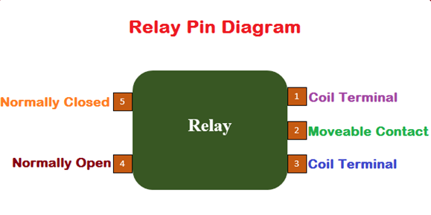

Fig2. Relay pin diagram (source by engineeringproject.com)

**RELAY INTERNAL STRUCTURE:-**

* Internal structure of any electronic device leads to the better understanding about its working principle.
* I have made a completely labeled internal structure of relay along with its pin configurations.

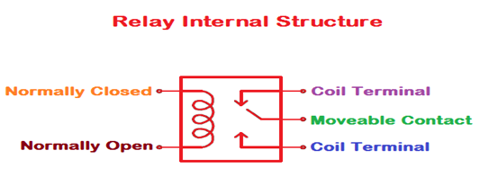

Fig.3 Internal structure (source by engineeringproject.com)

**RELAY PINOUT:-**

* If you want to know about the pin configuration of any electronic device you must have a look at its pinout diagram.
* Pinout diagram helps us to understand the pin configurations in a better way.
* I have made a pinout diagram which contains relay animation, internal structure and the real image.
* Relay pinout diagram is given in the figure shown below.

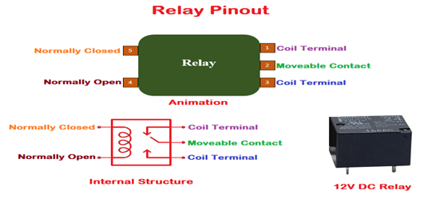

Fig. 4 Relay pinout (source by engineeringproject.com)

**Relay works on a pretty simple principle:**

* Initially when the power is not supplied and relay is in normally open condition, its contact will be opened.
* When relay is in normally closed condition, its contact will be closed.
* When power is supplied to its coil, it gets energized and its normally open condition is changed to normally closed and normally closed condition is changed to normally open.
* If we want to control the device via relay through a software then we have to attach this device to its normally open terminal.
* When the relay gets energized, that device will be turned on for the appropriate operation.
* Working principle of array can be understand from the visuals given in the figure shown below.
* Initially, when the power is not supplied and you can see the relay has normally closed contact as shown in the figure give below.

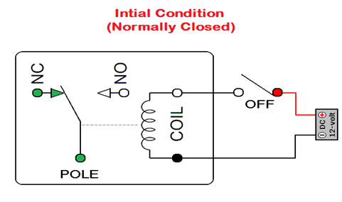

Fig.5 Initial condition for relay (source by engineeringproject.com)

* As I have told earlier, when we supply power the normally closed contact will changed its state to normally open contact and vice versa.
* The explanation of the above step is given in the figure shown below.

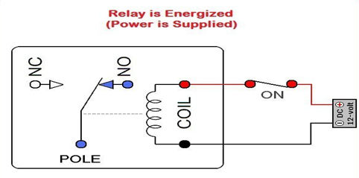

Fig.6 when voltage is applied to relay (source by engineeringproject.com)

1. **SOLENOID LOCK:-**

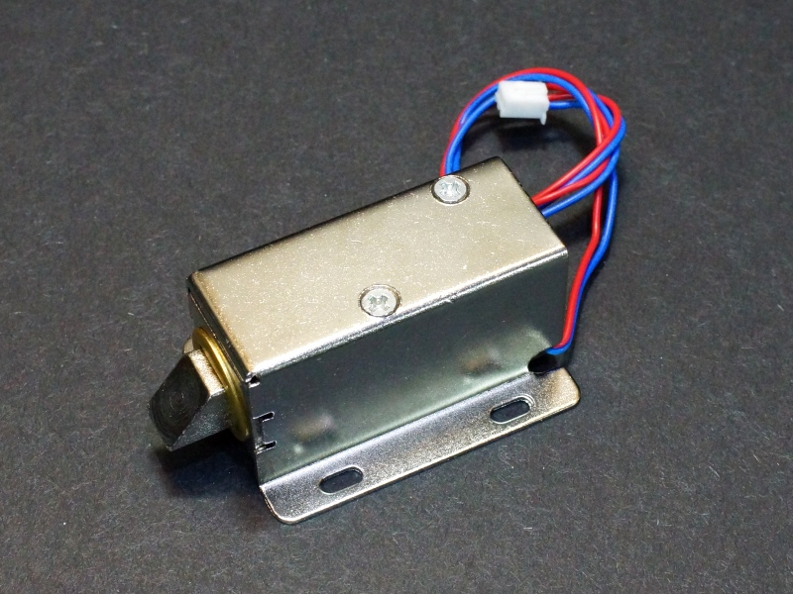

Fig.7 Solenoid door lock (source by protosupplies.com)

**Rating:-**

* **Rated voltage: DC 12V**
* **Rated current: 0.6A**
* **Rated Power: 7.5 Watt**
* **Body Material: Iron**

**Description**

Want to lock a door, drawer or any other moving part then this solenoid lock is perfect for you. You can interface this electromagnetic lock to any micro-controller, Arduino or even raspberry pi using a simple relay if you want you can directly use a one channel relay driver module. Solenoids are basically electromagnets: they are made of a big coil of copper wire with an armature (a slug of metal) in the middle. When the coil is energized, the slug is pulled into the center of the coil. This makes the solenoid able to pull from one end. This solenoid, in particular, is nice and strong and has a slug with a slanted cut and a good mounting bracket. It's basically an electronic lock, designed for a basic cabinet or safe or door. Normally the lock is active so you can't open the door because the solenoid slug is in the way. It does not use any power in this state. When 9-12 Volt DC is applied, the slug pulls in so it doesn't stick out anymore and the door can be opened.

### **Features:**

* High quality ultra-compact electric lock.
* Rustproof, durable, safe, convenient to use.
* Suction which tightly sucks the iron, thus locking the door.
* Applicable for being installed in the escape door or fire door electronic controlled system.
* Adopts the principle of electric magnetism, when the current through the silicon, the electromagnetic lock will achieve a strong.

### **Dimension:**

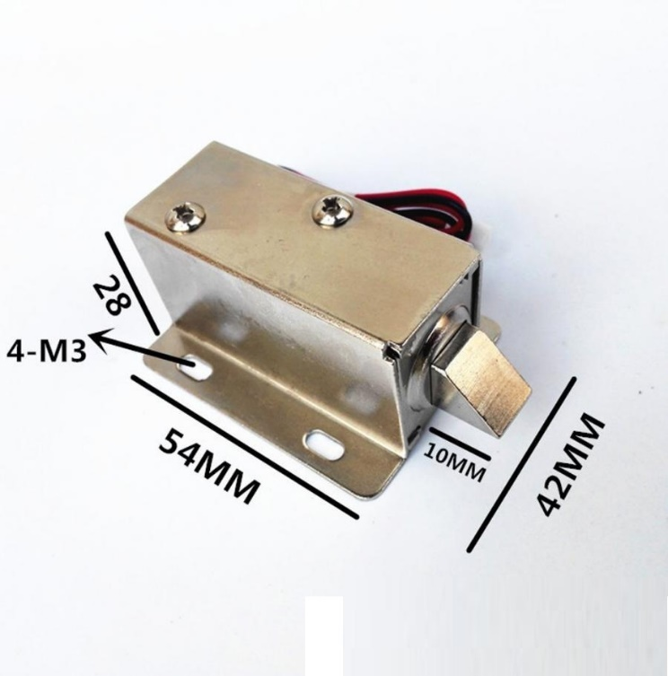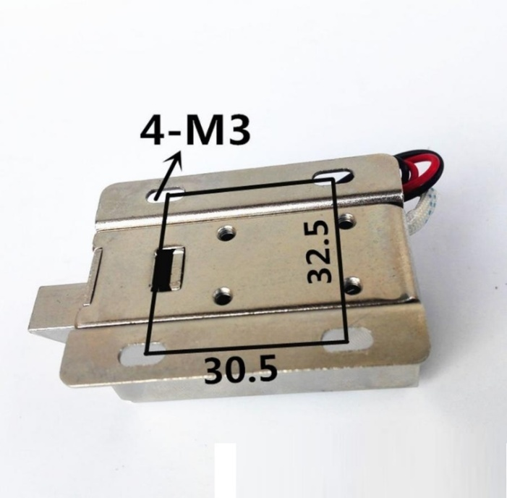

* 1. Upper view 2. Lower view

Fig.8 Upper and lower view of solenoid lock (source by protosupplies.com)

1. **POWER SUPPLY:-**

**Introduction**

In most of our electronic products or projects we need a power supply for converting mains AC voltage to a regulated DC voltage. For making a power supply designing of each and every component is essential. Here to discuss the designing of regulated 5V Power Supply.

**Block Diagram of Power Supply**

Figure show the block diagram of power supply. It can be divided into following stages:

Stage1: Transformer

Stage 2: Rectifier

Stage 3: Filter

Stage 4: Regulator

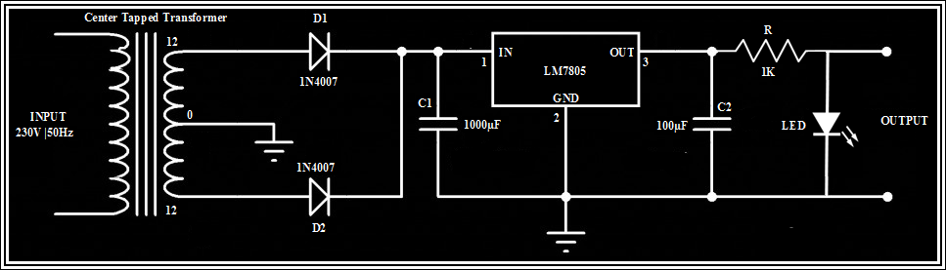

Fig.9 Circuit Diagram of Power Supply.

**Transformer:-**

A transformer is a static electrical device that transfers energy by inductive coupling between its winding circuits. A varying current in the primary winding creates a varying magnetic flux in the transformer's core and thus a varying magnetic flux through the secondary winding. This varying magnetic flux induces a varying electromotive force (EMF) or voltage in the secondary winding. Commonly, transformers are used to increase or decrease the voltages of alternating current in electric power applications.

A wide range of transformer designs are used in electronic and electric power applications. Transformers are essential for the transmission, distribution, and utilization of electrical energy.

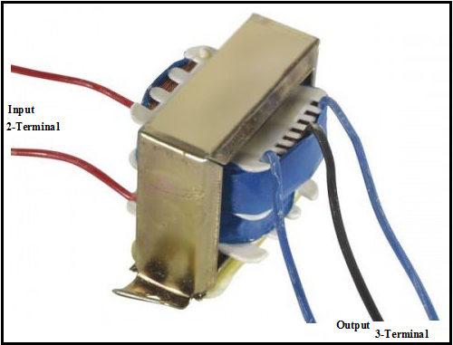

Fig.10 Centre Tapped Transformer

**Rectifier:-**

A rectifier is an electrical device that converts alternating current (AC), which periodically reverses direction, to direct current (DC), which flows in only one direction. The process is known as rectification. Physically, rectifiers take a number of forms, including vacuum tube diodes, mercury-arc valves, copper and selenium oxide rectifiers, solid-state diodes, silicon-controlled rectifiers and other silicon-based semiconductor switches. Historically, even synchronous electromechanical switches and motors have been used. Early radio receivers, called crystal radios, used a "cat's whisker" of fine wire pressing on a crystal of galena (lead sulphide) to serve as a point-contact rectifier or "crystal detector".

A more complex circuitry device which performs the opposite function, converting DC to AC, is known as an inverter.

Rectification based on Full Wave Rectifier either using 4-diode or using 2-diode are shown as:

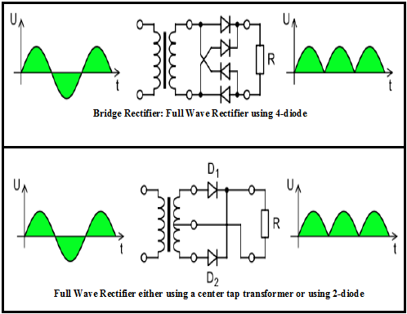

Fig.11 Rectification.

**Filter Capacitor:-**

Filter capacitors are capacitors used for filtering of undesirable frequencies. Figure 12 show the Full wave rectifier with a capacitor filter.

They are common in electrical and electronic equipment, and cover a number of applications, such as:

1. Glitch removal on Direct current (DC) power rails
2. Radio frequency interference (RFI) removal for signal or power lines entering or leaving equipment

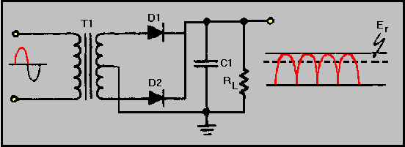

Fig.12 Full wave rectifier with a capacitor filter

1. Capacitors used after a voltage regulator to further smooth dc power supplies
2. Capacitors used in audio, intermediate frequency (IF) or radio frequency (RF) frequency filters (e.g. low pass, high pass, notch, etc.)

**Voltage Regulator:-**

A voltage regulator is designed to automatically maintain a constant voltage level. A voltage regulator may be a simple "feed-forward" design or may include negative feedback control loops. It may use an electromechanical mechanism, or electronic components. Depending on the design, it may be used to regulate one or more AC or DC voltages.

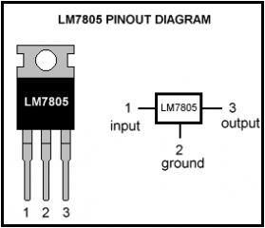

Fig. 13 LM7805 – Pin Diagram

Electronic voltage regulators are found in devices such as computer power supplies where they stabilize the DC voltages used by the processor and other elements. In automobile alternators and central power station generator plants, voltage regulators control the output of the plant. As we require a 5V we need LM7805 Voltage Regulator IC shown in Figure 2.6.

7805 IC Rating:

1. Input voltage range 7V- 35V
2. Current rating Ic = 1A
3. Output voltage range VMax=5.2V, VMin=4.8V.

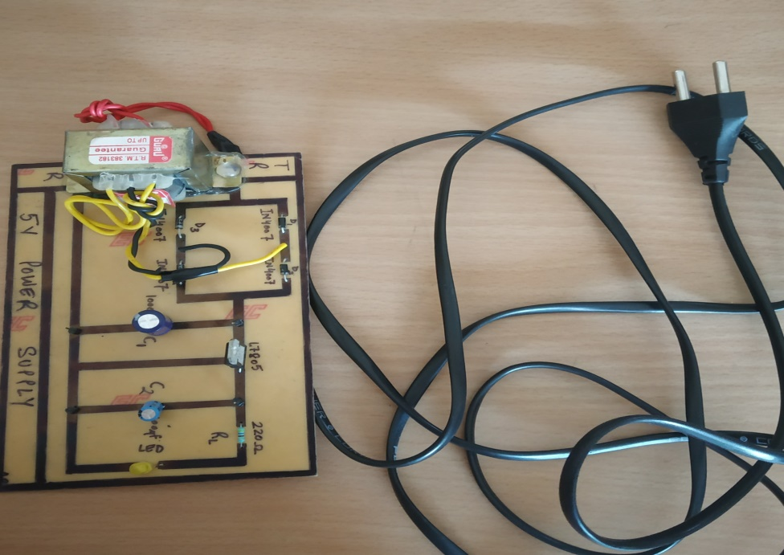

Fig.14 5/12 VOLT POWER SUPPLY

1. **ARDUINO DETAILS:-**

**Introduction**

Arduino interface boards provide the engineers, artists, designers, hobbyists and anyone who tinker with technology with a low-cost, easy-to-use technology to create their creative, interactive objects, useful projects etc. A whole new breed of projects can now be built that can be controlled from a computer.

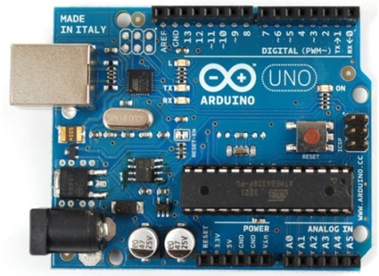

Fig. 15 Arduino UNO

Arduino is an open source electronics prototyping platform based on flexible, easy-to-use hardware and software. It’s intended for artists, designers, hobbyists, and anyone interested in creating interactive objects or environments. It’s an open-source physical computing platform based on a microcontroller board, and a development environment for writing software for the board.

In simple words, Arduino is a small microcontroller board with a USB plug to connect to your computer and a number of connection sockets that can be wired up to external electronics, such as motors, relays, light sensors, laser diodes, loudspeakers, microphones, etc. They can either be powered through the USB connection from the computer or from a 9V battery. They can be controlled from the computer or programmed by the computer and then disconnected and allowed to work independently.

Anyone can buy this device through online auction site or search engine. Since theArduino is an open-source hardware designs and create their own clones of the Arduino and sell them, so the market for the boards is competitive. An official Arduinocostsabout $30 and a clone often less than $20.

The name “Arduino” is reserved by the original makers. However, clone Arduino designs often have the letters “duino” on the end of their name, for example, Freeduino or DFRduino. The software for programming your Arduino is easy to use and also freely available for Windows, Mac, and LINUX computers at no cost.

**HARDWARE:-**

**Arduino Board Layout**

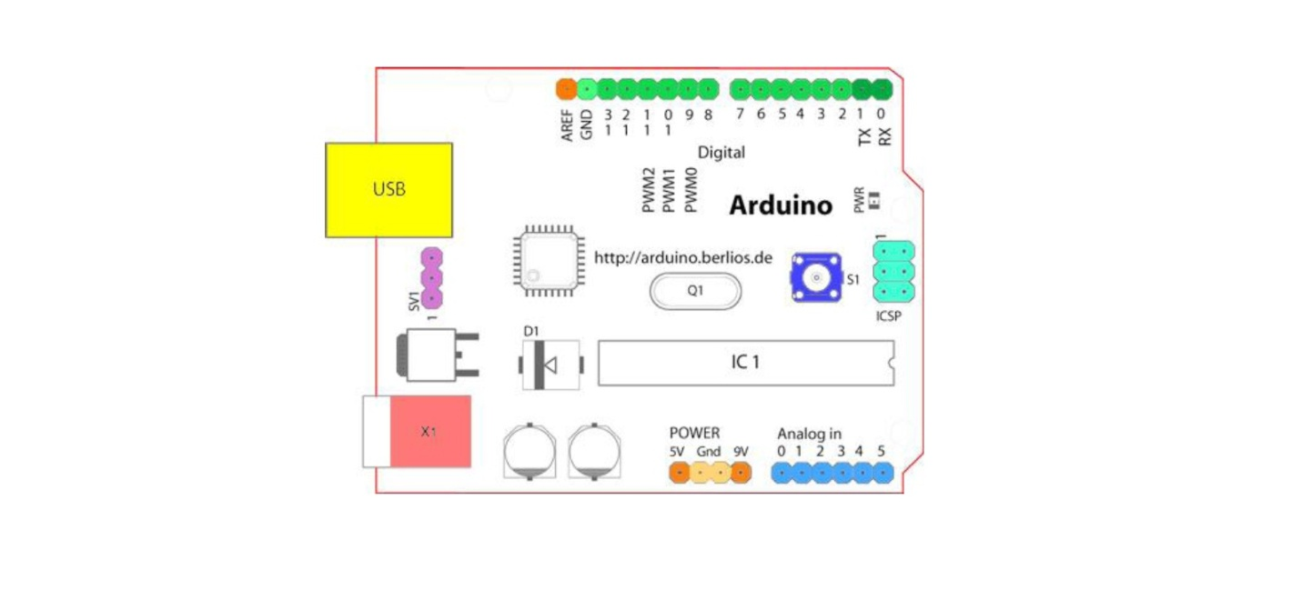

Fig. 16 Arduino Board Layout

**Arduino Pin Diagram:-**

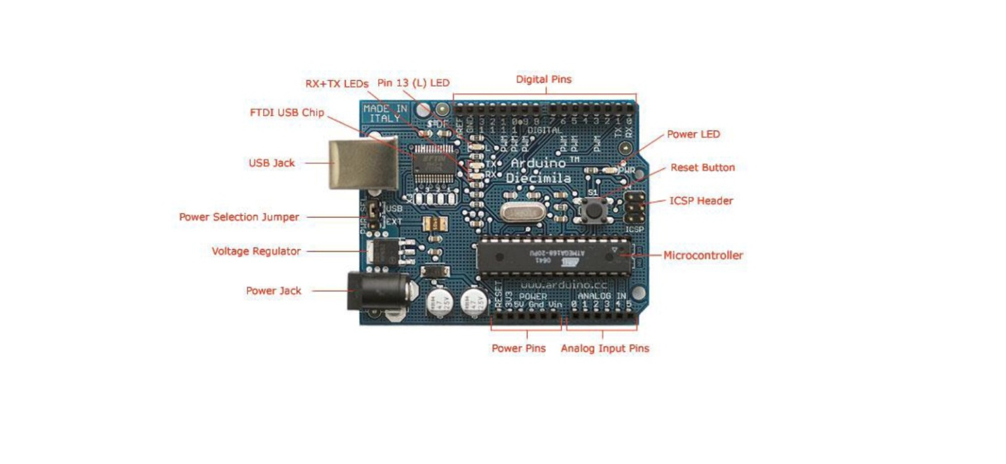

Fig.17 Arduino Pin Diagram

**External Power:-**

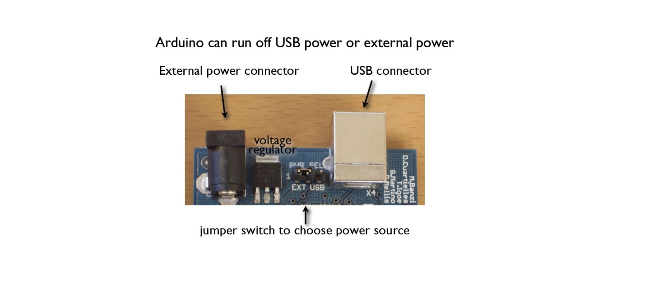

Fig.18 External Power Source

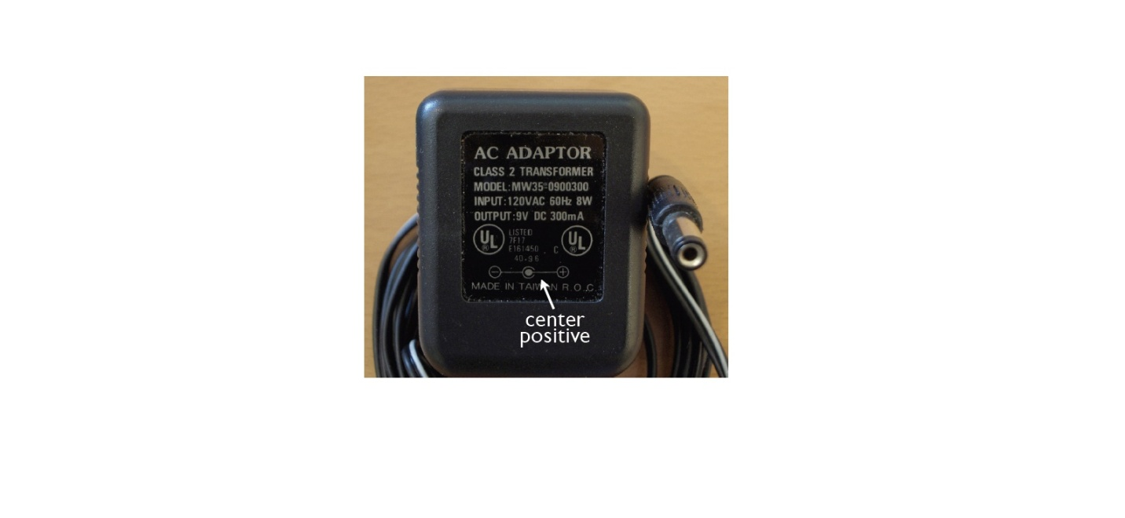

Fig. 19 AC Adapter

The power requirement for ARDUINO is 9 to 12V DC, 250 mA or more, 2.1mm plug, centre pin positive.

**The OFF- The Shelf Adapter**

* must be a DC adapter (i.e. it has to put out DC, not AC)
* should be between 9V and 12V DC
* must be rated for a minimum of 250mA current output, although you will likely want something more like 500mA or 1A output, as it gives you the current necessary to power a servo or twenty LEDs if you want to.
* must have a 2.1mm power plug on the Arduino end, and
* The plug must be "centre positive", that is, the middle pin of the plug has to be the + connection.

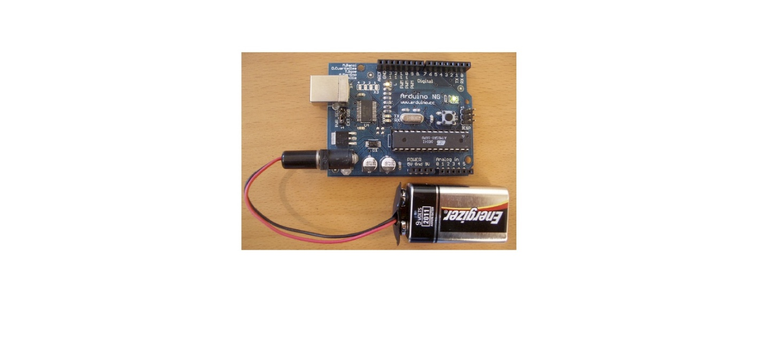

Fig. 20 AC Adapter

**Current rating:** Since you'll probably be connecting other things to the Arduino (LEDs, LCDs, servos) you should get an adapter that can supply at least 500mA, or even 1000 mA (1 ampere). That way you can be sure you have enough juice to make each component of the circuit function reliably.

The Arduino's on-board regulator can actually handle up to 20V or more, so you can actually use an adapter that puts out 20V DC. The reasons you don't want to do that are twofold: you'll lose most of that voltage in heat, which is terribly inefficient. Secondly, the nice 9V pin on the Arduino board will actually be putting out 20V or so, which could lead to potential disaster when you connect something expensive to what you thought was the 9V pin. Our advice is to stick with the 9V or 12V DC adapter.

**Applications of Arduino:-**

Arduino was basically designs to make the process of using electronics in multidisciplinary projects more accessible. It is intended for artists, designers, hobbyists, and anyone interested in creating interactive objects or environments. Arduino can sense the environment by receiving input from a variety of sensors and can affect its surroundings by controlling lights, motors, and other actuators. Because of these features, Arduino finds extensive application in various fields. Arduino projects can be stand-alone or they can communicate with software running on a computer.

Arduino is used by all class of people in a different way. Some students use it in their projects, some using Arduino for fun; some went out to become entrepreneurs. This only show how useful is this tiny device.

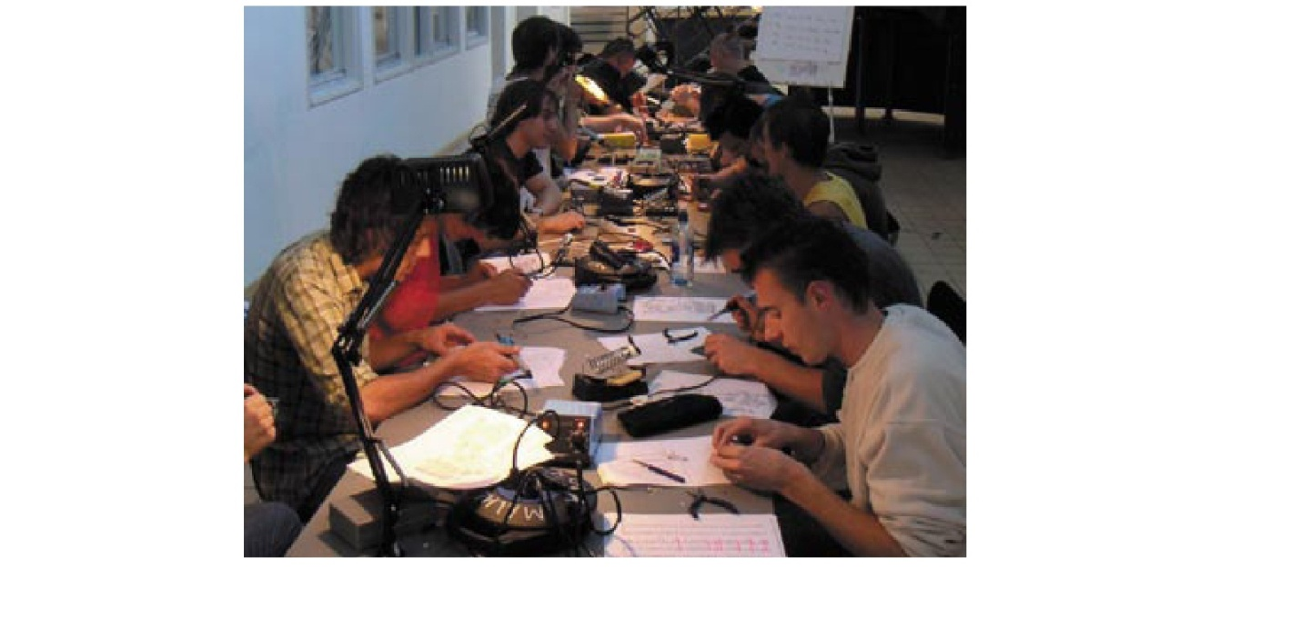

Fig.21 Arduino Fever

ARDUINO is spreading rapidly across the globe.Arduino is actually an open source hardware project that can be programmed to read temperatures, control a motor, and sense touch. The Arduino is both a cute, blue microcontroller platform that fits nicely in the palm of your hand and an expanding community of developers who support it, distributed across two dozen countries, four continents, and counting.

The Arduino board is for anyone who wants to build a basic level of intelligence into an object. Once programmed, it can read sensors, make simple decisions, and control myriad devices in the real world. Using it is a snap: first, hook up a few sensors and output devices to the Arduino, and then program it using the free developer’s software. Next, debug your code and disconnect the Arduino. Then, the little blue Arduino becomes a standalone computer.

The original intention of the Arduino project was to see what would happen if community support were substituted for the corporate support that is usually required for electronics development. The first developers — Massimo Banzi, David Cuatrilloes, David Mellis, and Nicholas Zambetti — ran a series of workshops on assembling the Arduino, giving away the board to stimulate development.

Thousands of projects have been done worldwide using this tiny little device. Some of which to mention are:

1. Simple room temperature readout
2. Interactive real-time auditory feedback system
3. GPS receiver Module
4. Ultrasonic Sensor
5. Infrared detectors
6. SONAR
7. Various sensor projects like
   * Keypad security code
   * Sensor tube for heart monitor
8. Various light projects like

* Multicolor light display
* Seven-segment LED display
* Double seven-segment LED dice
* LED array
* LCD module

1. Various sound projects like
   * Oscilloscope
   * Light harp
   * VU meter
2. Various power projects like
   * LCD Thermostat
   * Computer controlled fan
   * The hypnotizer
3. Miscellaneous Projects like
   * Lie detector
   * Magnetic door lock
   * Infrared remote
   * Lily pad binary clock.
4. **9 VOLT BATTERY:-**

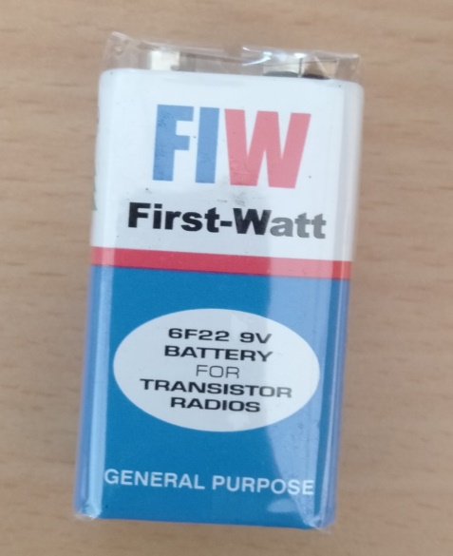

Fig. 22

* Model Number: 9V 6F22
* Battery Type: Zinc Carbon
* Size: 6F22 006P
* Jacket: Metal
* Single Battery Dimensions (mm): L- 26. 5, H - 48. 5, W - 17. 5 (Max)
* Nominal Voltage(V) :9V
* Discharge Resistance(Ω): 620
* Cut-off Voltage(V): 5.4

**JUMPER WIRES:-**

Jumper wires are simply wires that have connector pins at each end, allowing them to be used to connect two points to each other without soldering. Jumper wires are typically used with [breadboards](https://blog.sparkfuneducation.com/what-is-a-breadboard) and other prototyping tools in order to make it easy to change a circuit as needed. Fairly simple. In fact, it doesn’t get much more basic than jumper wires.

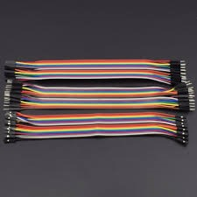

Fig. 23

Though jumper wires come in a variety of colors, the colors don’t actually mean anything. This means that a red jumper wire is technically the same as a black one. But the colors can be used to your advantage in order to differentiate between types of connections, such as ground or power.

While jumper wires are easy and inexpensive to purchase, it can also be a fun task to [challenge students to make their own](http://www.dummies.com/programming/electronics/how-to-make-jumper-wires/). Doing so requires insulated wire and wire strippers. However, beware that it is important not to nick the wire when stripping off the insulation.

**Types of Jumper Wires:-**

Jumper wires typically come in three versions:

* male-to-male

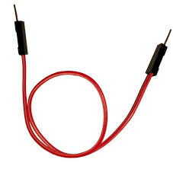

Fig.24

* male-to-female

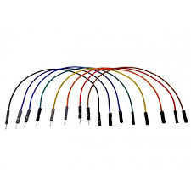

Fig. 25

* Female-to-female

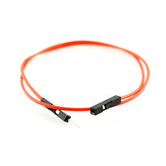

Fig.26

The difference between each is in the end point of the wire. Male ends have a pin protruding and can plug into things, while female ends do not and are used to plug things into. Male-to-male jumper wires are the most common and what you likely will use most often. When connecting two ports on a breadboard, a male-to-male wire is what you’ll need.

**METHODOLOGY:-**

All the components mentioned in this report are used to make “Voice recognition door lock” project.

The main part of this project is voice recognition module.

This module is used to record the voice of a particular person.

### Features of ‘Voice recognition module’:-

* Support maximum 80 voice commands, with each voice 1500ms (one or two words speaking)
* Maximum 7 voice commands effective at same time
* Arduino library is supplied
* Easy Control: UART/GPIO
* User-control General Pin Output

**CONNECTIONS:-**

**Input connection:-**

|  |  |  |
| --- | --- | --- |
| **Arduino** | **Relay** | **Voice recognition v3** |
| **Vcc1(3.3V)** | - | Vcc |
| **Vcc2(5V)** | Vcc | - |
| **Gnd1** | - | Gnd |
| **Gnd2** | Gnd | - |
| **Pin9** | Input | - |
| **Pin2** | - | Tx |
| **Pin3** | - | Rx |

**Output connection:-**

|  |  |  |
| --- | --- | --- |
| **PARAMETERS** | **POWER SUPPLY(12V)** | **SOLENOID LOCK(12V)** |
| **Relay Common** | +12V APPLIED | - |
| **Relay NO(Normally Open)** | - | +12V RECIEVED |
| **Relay NC(Normally Closed)** |  |  |
| **-ve connection (solenoid lock and 12v power supply)** | GND | GND |

**WORKING:-**

Voice recognition module library: <https://github.com/elechouse/VoiceRecognitionV3>

* + 1. Download Arduino software.
    2. Programming in software is written in C language.
    3. Add the libraries of Voice recognition module with above link so that the program can run.
    4. Firstly do the connection of the circuit as mentioned above in the table.
    5. Now connect the lead with Arduino.

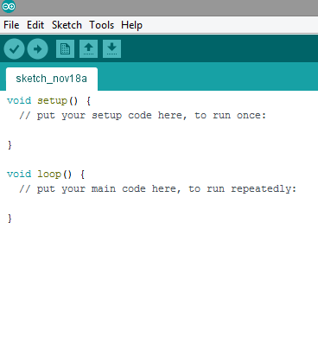

Fig.27

* + 1. Fig.27 shows the first page when the software is open.
    2. With the help of above link download he library file for Arduino.
    3. Add those libraries in the software.

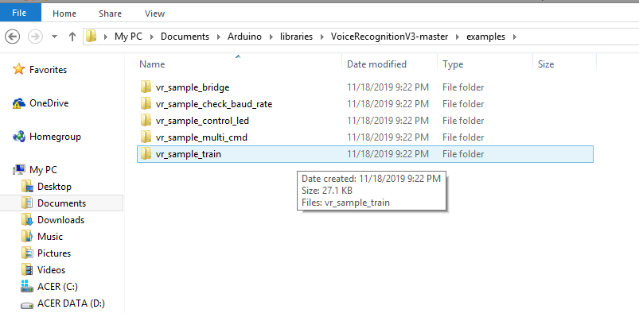

Fig.28

* + 1. Now open the vr_sample_train library to train the Voice recognition module as shown in Fig.28
    2. Connect the lead to the Arduino with laptop.
    3. Select the correct Port and Board as shown in fig.29

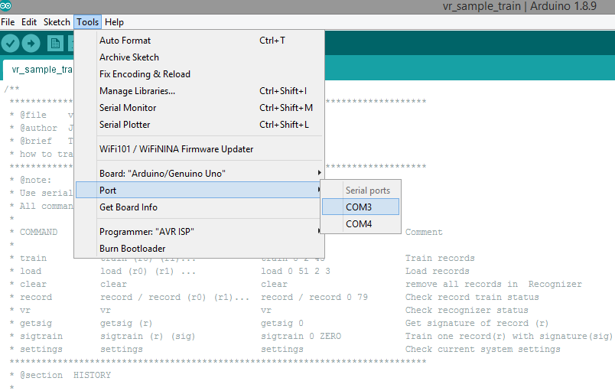

Fig.29

* + 1. Run The Program.
    2. Open the serial monitor and check the settings of Voice Recognition v3.
    3. Train the Module by using ‘Sigtrain’ Command on serial monitor as shown in Fig.30
    4. Record the 1st voice y using ‘sigtrain 0’ command with ‘open’ signature.

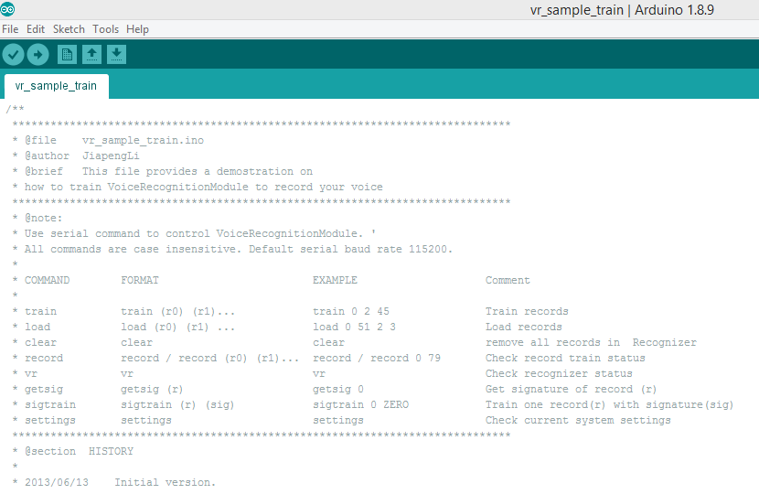

Fig.30

* + 1. Speak the Password you want to set to open the lock.
    2. When the module is trained stop speaking.
    3. Use other command ‘sigtrain 1’.
    4. Speak the password you want to set to close the lock.
    5. After training the module load the voices by using ‘load 0 1’ command.
    6. Now the voices are recorded with signature.
    7. Now write other program to control the relay so that it control the solenoid lock as shown in Fig.31

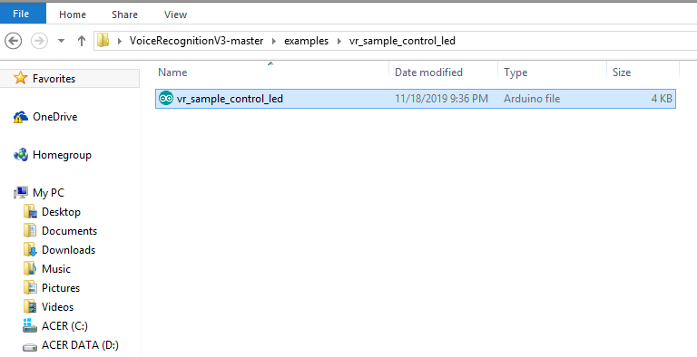

Fig.31

* + 1. Do some changes so that the relay can switch.
    2. When the password is told by the person (whose voice was recorded) the voice recognition module send signal to the Arduino.
    3. The Arduino decode the signal and high signal is send to the relay so that it can switch from NC to NO.
    4. The +12v is given to COMMON of the relay.
    5. +12v is provided by the POWER SUPPLY to the COMMON of relay.
    6. The NO is connected with the +ve terminal of Solenoid lock.
    7. The –ve terminal of POWER SUPPLY is directly connected to the –ve terminal of solenoid lock.
    8. When signal is given to the input pin of relay through Pin9 of Arduino the COMMON terminal of relay get switched from NC to NO.
    9. The NO of relay is connected with +ve terminal of solenoid lock.
    10. Hence the circuit is completed which lead to the opening of Lock.
    11. Similarly when the person give the command to close the lock the signal is removed by arduino and the relay is Switched from NO to NC.
    12. The Solenoid circuit is disconnected through relay.
    13. Hence this is the working of the device.
    14. Fig.32 shows the connections and components of this project.

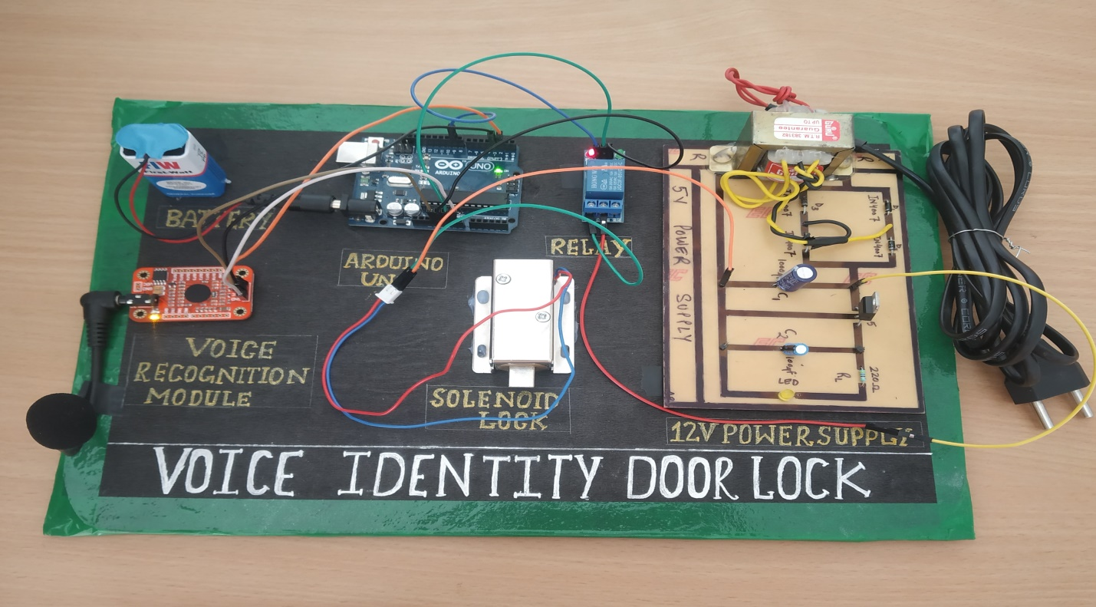

Fig. 32 Voice Identity Door Lock

**SECURITY CONCERNS:-**

We have to learn to talk consistently and clearly at all times to minimize errors.

If we mumble, talk too fast or run words into each other, the software will not be able to cope.

Programs may have problems recognizing speech as normal if our voice changes, e.g. when we have a cough, cold or throat problem.Speech Recognition can become a means of attack, theft, or accidental operations.

**PURPOSE OF THIS PROJECT:-**

It’s a new concept in embedded system and home automation. The main purpose of this project is

1. Security
2. Good False Acceptance Rate (FAR)
3. Good False Rejection Rate (FRR)
4. To make it cost effective
5. To make it available for person with disability(who cannot move their limbs but can speak and listen)
6. Also useful for blind people.

**REFERENCES:**

* Raj, L. D. W., Santhosh, K., Subash, S., Sujin, C., & Tharun, P. (2019, March). Voice Controlled Door Lock System Using Matlab and Arduino. In 2019 IEEE International Conference on System, Computation, Automation and Networking(ICSCAN) (pp. 1-6). IEEE.
* Upadhyay, A. (2019). Voice based home automation using Arduino.
* Kamdar, H., Karkera, R., Khanna, A., Kulkarni, P., & Agrawal, S. (2017). A review on home automation using voice recognition. International Research Journal of Engineering and Technology *(IRJET)*, *4*(10).
* Sushant Kumar and S.S. Solanki, “Voice and Touch Control Automation”, 3rd Int’l Conf. on Recent Advances in Information Technology, 2016.
* Aml A. Arriany and Mohamed S.Musbah, “Applying Voice Recognition Technology for Smart Home Networks”, IEEE 2016.
* Yash Mittal and Sonal Sharma, “A Voice-Controlled Multi-Functional Smart Home Automation System”, IEEE Indicon 2015.
* Mukesh Kumar, Shimi S.L. ,“Voice Recognition Based Home Automation System for Paralyzed People”, International Journal of Advanced Research in Electronics and Communication Engineering (IJARECE) Volume 4, Issue 10, October 2015
* D. Gann, J. Barlow, and T. Venables, “Digital Futures: making homes smarter”. Citeseer, 1999.
* J. Picone, “Fundamentals of speech recognition: A short course,” Institute for Signal and Information Processing, Mississippi State University, 1996.
* L. J. Kaila, “Technologies enabling smart homes,” Tampereen teknillinen yliopisto Julkaisu-Tampere University of Technology. Publication; 846, 2009.
* P. Rashidi and D. Cook, “Keeping the Resident in the Loop: Adapting the Smart Home to the User,” IEEE Transactions on Systems, Man and Cybernetics, Part A: Systems and Humans, vol. 39, no. 5, pp. 949–959, Sep 2009.
* Elechouse, “Arduino library for Elechouse Voice Recognition V3 module,” 2013, [Last accessed on 16 Jun 2015].
* Mitali Patil, Ashwini Bedara, Varsha Pacharne, “The Design and Implementation of Voice Controlled Wireless Intelligent Home Automation System based on Zigbee”; Volume 2, Issue 4 April 2013.
* T.Kirankumarand B. Bhavani, “A Sustainable Automated System for Elderly People Using Voice Recognition and Touch Screen Technology International Journal of Science and Research (IJSR), vol. 2, pp. 265-267, August 2013.
* P. Rashidi and D. Cook, “Keeping the Resident in the Loop: Adapting the Smart Home to the User,” IEEE Transactions on Systems, Man and Cybernetics, Part A: Systems and Humans, vol. 39, no. 5, pp. 949–959,Sep 2009.
* Kaur, I. (2010). Microcontroller based home automation system with security. International journal of advanced computer science and applications, 1(6), 60-65.
* "U.S. Patent 613809: Method of and apparatus for controlling mechanism of moving vessels and vehicles". United States Patent and Trademark Office. 1898-11-08. Retrieved 2010-06-16.